**Front-end challenge**

•        Getting Started

* Prerequisites (Environment used)

Angular CLI: 8.3.8

* External dependency used

ol package from npm (for OpenLayers)

•        Technologies used:

o   Angular

•        Get code for front end from git repository

* Run 'npm install' command at same location
* Run npm install ol –save
* After successfully having node modules in code, run 'ng serve' command, application is up and running on default port (4200)
* For production build – ‘ng build –prod’

•        In browser window, hit following url

<http://localhost:4200/>

Public git repository – <https://github.com/mrinaliniwaghmare/BirdTrackInformation.git>

**Evidences –**

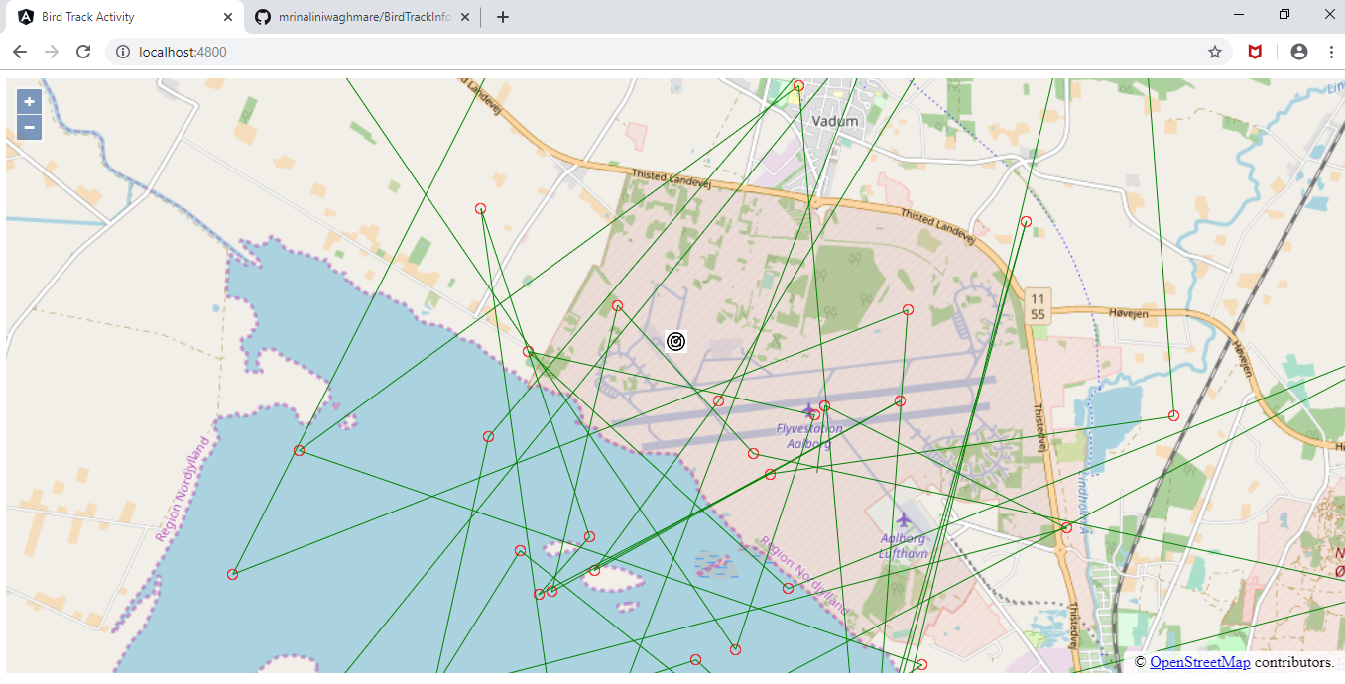

**Interpretation of the problem statement**

1. Processed radar data for bird track activity has been provided with geojson files.
2. Understanding details from geojson files.
3. Use OpenLayers (preferred) to show webmap.
4. Show radar at center of the map and crop map at 10 km from center.
5. Show individual bird tracks
6. Change projection of map based on requirement

**Approach to solution**

1. Use OpenLayers (preferred) to show webmap
2. Target one geojson file to show radar and bird track

* Show webmap with OpenLayers
* Geojson input to get center of the map
* Use icon to show radar at center of the map as mentioned in requirements
* Locate rest of the feature coordinates to show bird track activity
* Either use track length and direction to show bird track or route feature of OpenLayers

1. Use similar logic for rest of the input files and show bird track activity with other geojson inputs
2. Implementation to change projection of map based on requirement

**Tasks Accomplished**

Get into learning of OpenLayers since I had not used it before, it was indeed a great learning

* Use OpenLayers (preferred) to show webmap, OpenLayers feature used – Map with zoom in and zoom out
* For one geojson file (7007.geojson), show radar at center of the map, OpenLayers feature used – Icon Symbolizer
* Crop the map at 10km from center, OpenLayers feature used – ‘transform’ from ol/proj
* Locate rest of the feature coordinates to show bird track activity, OpenLayers feature ­­used – mark every coordinate with point and use OpenLayers LineString to show complete track­­

**Outstanding Tasks**

* Use OpenLayers route feature to show bird activity
* Use geojson details like track length and track direction to show exact bird activity
* Accomplish the same for rest of the geojson file inputs
* Implementation to change projection of map based on requirement
* Use test driven development approach (using jasmine and karma for unit test cases)